Non-Employee Travel Checklist

Job Candidates

☐ Transportation
  - Airline
  - Car Rental
  - Mileage
  - Uber/Lyft/Taxi Service

☐ Lodging
- To be booked locally by Dept. AA (or Provost’s Staff Associate if using Provost’s account) and billed directly to campus.
  - Dept. AA to submit as a PO via RDD.

☐ Meals
- Itemized receipts must be included for meals on their own.
  - Meal per diems do NOT apply to non-employees.
  - Alcohol will not be reimbursed.

☐ Candidate’s Interview Agenda/Itinerary
- Include copy with backup

☐ Standard Voucher
- Areas to complete on Standard Voucher:

Top portion – Payee Information
Do NOT add SSN
- Payee Name (first & last)
- Email Address
- Address (Street, City, State Zip)
        - (where the check will be mailed to)

Middle Section – Description of Material/Service
- Dates and itemized listing of expenses (i.e. airfare, rental car, mileage, meals)
  - Per Diem Rates do NOT apply to non-employees.
  - Itemized receipts required (without, they will not be reimbursed for that meal)
- Total Travel Expenses
- Net = Grand Total to be reimbursed

Payee Certification
- Job Candidate signs (no digital or e-signature allowed)
- Date

Supervisor’s Certification
- Department Chair signs (no digital or e-signature allowed)
- Title
- Date

Cost Center Unit
- Add account # to charge
- Receipts and Backup
  - ☐ Scan all receipts & backup and combine into 1 PDF with Standard Voucher.
    - ☐ Email fully signed Standard Voucher and backup to accounts.payable@cortland.edu.
Standard Voucher cannot be digitally or e-signed.

Signature Types:
NOT Allowed:
- Typed signature:
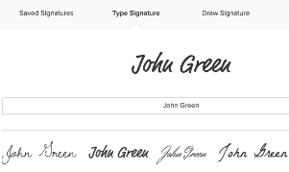
- Digital Signature:
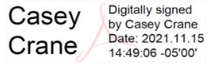
ALLOWED (original signature scanned):
- Original, scanned
